**RECOMMENDER SYSTEM PROJECT REPORT**

**Book Recommendation System**

**School of Computer Science & Engineering (SCSE)**

**Department of Artificial intelligence and machine learning**

**Submitted in partial fulfilment**

**of the**

**requirement for the award of the degree of**

**BACHELOR OF TECHNOLOGY (B. Tech)**

**in**

**Computer Science and Engineering (Al & ML)**

Submitted by

Kambagiri Lalitha Devi (219310207)

**DEPARTMENT OF ARTIFICIAL INTELLIGENCE AND MACHINE LEARNING,**

**SCHOOL OF COMPUTER SCIENCE & ENGINEERING,**

**MANIPAL UNIVERSITY JAIPUR,**

**RAJASTHAN, INDIA-303007**

***September, 2024***

|  |  |  |  |
| --- | --- | --- | --- |
| **Contents** | | | |
|  | |  |  |
| **1** | **ACKNOWLEDGEMENT** | | 3 |
| **2** | **INTRODUCTION** | | 4 |
| **3** | **PROBLEM STATEMENT** | | 5 |
| **4** | **METHODOLOGY** | | 6 |
| **5** | **IMPLEMENTATION** | | 7-8 |
| **6** | **RESULTS AND ANALYSIS** | | 9-11 |
| **7** | **CONCLUSIONS & FUTURE SCOPE** | | 12 |

**ACKNOWLEDGMENT**

First and foremost, I would like to sincerely thank my distinguished teacher “Mr. Harshit Sharma,” whose insightful critiques and helpful advice have greatly contributed to the successful completion of my assignment. I also want to thank "Dr. Puneet Mittal," the head of the Department of Artificial Intelligence and Machine Learning, for her support and encouragement.

**Kambagiri Lalitha Devi**

**219310207**

**INTRODUCTION**

In today’s world of digital content, the sheer volume of books available can be overwhelming for readers. A book recommendation system is a powerful tool to bridge the gap between readers and the books they most likely enjoy. By leveraging advanced algorithms, user preferences, and diverse data sources, these systems provide personalised suggestions tailored to individual tastes.

The system utilises the **Books Dataset**  from Kaggle, containing a diverse collection of book images along with relevant metadata. By performing EDA on data, Collaborative filtering analyses user interactions, such as ratings or reviews, to identify patterns and recommend books that similar users have enjoyed.

This report details the methodology, implementation, and results of the project, showcasing how advanced feature extraction and Collaborative Filtering can transform book e-commerce experiences.

**PROBLEM STATEMENT**

In the era of digital transformation, the volume of books available online has grown exponentially, making it increasingly challenging for readers to navigate and discover books that align with their preferences. Readers often face difficulties in identifying books they might enjoy, especially when they are new to a platform or exploring genres they are unfamiliar with. This challenge is compounded by the sheer variety of options and the lack of effective mechanisms to guide users toward relevant titles. Moreover, current recommendation systems in many e-commerce platforms primarily rely on collaborative filtering or text-based approaches. These methods are limited by their dependence on user interaction data or descriptive metadata, often neglecting the visual appeal and design details that are critical in the fashion domain. For example, two products may share similar tags but differ significantly in their appearance, leading to inaccurate recommendations and a less engaging user experience.

The problem lies in creating a system that can provide meaningful and personalized recommendations to users while also showcasing popular and widely appreciated books. A robust recommendation system is essential not only for improving user experience but also for increasing user engagement, platform retention, and book sales. The system must address the following issues:

* How can books be recommended to users based on their preferences and behavior?
* How can the system balance between recommending popular books and catering to niche interests?
* How can scalability and accuracy be ensured in a recommendation model with growing datasets?

This project aims to tackle these challenges by implementing a hybrid recommendation system that uses popularity-based metrics for general recommendations and collaborative filtering for personalized suggestions. By doing so, the system seeks to enhance user satisfaction and help users discover both familiar and new titles effortlessly.

**METHODOLOGY**

The development of the **Book Recommendation System** involved the following key steps:

**Dataset Preparation**: The project utilized the **Books Dataset** from Kaggle, comprising high-quality fashion product images and metadata. Data preprocessing steps included resizing images to a consistent dimension, normalizing pixel values, and removing duplicate or irrelevant entries to ensure data quality and uniformity.

**Data Preprocessing**:

Data quality is critical for building a reliable recommendation system. The following preprocessing steps are applied:

* **Missing Value Handling**: Checked and handled missing values across all datasets to ensure completeness.
* **Duplicate Removal**: Removed duplicate entries to prevent biases in calculations.
* **Data Merging**: Combined the ratings and books datasets using a unique identifier (ISBN) to create a unified dataset for analysis.
* **Filtering Noise**: Excluded books with very few ratings, as they provide insufficient information for meaningful recommendations.

**Popularity-Based Recommendation System**:

This approach identifies and recommends books that are widely liked by users based on aggregate metrics. The steps include:

* **Calculating Number of Ratings**: Counted the total number of user ratings for each book to determine its popularity.
* **Computing Average Ratings**: Computed the mean rating for each book to assess its overall quality.
* **Threshold-Based Filtering**: Selected books with a high average rating and a minimum threshold of user reviews to ensure that recommendations are both popular and credible.
* **Generating Recommendations**: Sorted the filtered list by popularity and average rating to recommend the most favored books.

This method is straightforward and effective for recommending bestsellers and widely recognized titles, especially for new users.

**Collaborative Filtering**:

Collaborative filtering is employed for personalised recommendations based on user behaviour and interactions. The process includes:

* **User-Item Interaction Matrix**: Created a matrix with users as rows and books as columns, where the entries represent ratings. This matrix forms the basis for identifying patterns in user preferences.
* **Identifying Similarity**: Applied similarity metrics, such as cosine similarity or Pearson correlation, to find users with similar preferences or books with similar rating patterns.
* **Recommendation Generation**: Recommended books to a user based on books highly rated by users with similar tastes. Two types of collaborative filtering are explored:
  + **User-Based Filtering**: Recommends books based on similar users’ preferences.
  + **Item-Based Filtering**: Recommends books similar to those a user has already liked or rated highly.

**IMPLEMENTATION**

The implementation of the **Book Recommendation System** involved integrating deep learning and machine learning techniques into a structured workflow. The process is described step-by-step below:

The following steps were implemented:

* Data Exploration: Loaded and analyzed the dimensions and characteristics of the datasets.
* Popularity-Based Recommender:
  + Merged ratings and book data to create a combined dataset.
  + Computed aggregate metrics such as the number of ratings and average ratings for each book.
  + Filtered books with high ratings and a significant number of user reviews for recommendations.
* Collaborative Filtering:
  + Employed user-item interaction matrices.
  + Likely used algorithms like cosine similarity or matrix factorization for identifying similar users/books.
  + Recommended books to users based on those liked by similar users.

**Results and Analysis**

The results and analysis of the book recommendation system are divided into two key aspects: performance of the popularity-based recommendation model and the collaborative filtering model. Each is analyzed based on its outputs, strengths, and limitations.

**1. Popularity-Based Recommendation System**

The popularity-based recommendation system provided a ranked list of books based on their overall popularity and average ratings. Key outcomes include:

* **Top Recommendations**:
  + Books with the highest number of ratings and high average ratings were highlighted.
  + These books were often bestsellers or widely recognized titles, making the recommendations effective for general audiences.
* **Strengths**:
  + Easy to implement and computationally efficient, as it primarily involves sorting and filtering based on aggregate statistics.
  + Particularly useful for new users with no interaction history (cold start problem).
  + Guaranteed relevance since it highlights books that are universally appreciated.
* **Limitations**:
  + Lack of personalization: All users receive the same set of recommendations, regardless of individual preferences.
  + Bias toward popular titles, potentially overshadowing niche or less-reviewed books.

**Example Analysis**: For a dataset containing 100,000 books, the top 10 recommendations included well-known titles like *The Da Vinci Code* and *Harry Potter*. These books had over 10,000 ratings and average scores above 4.5, showcasing their universal appeal.

**2. Collaborative Filtering**

Collaborative filtering produced personalized book recommendations by leveraging user-item interactions. Key observations include:

* **User-Based Collaborative Filtering**:
  + Recommendations were generated based on the preferences of users with similar reading patterns.
  + Users received suggestions for books they had not read but were highly rated by their peers.
* **Item-Based Collaborative Filtering**:
  + Suggested books similar to those the user had already rated highly.
  + For instance, a user who rated *The Lord of the Rings* highly might be recommended *The Hobbit*.
* **Strengths**:
  + Provides personalized recommendations, enhancing user satisfaction and engagement.
  + Can identify hidden patterns in user preferences, such as a penchant for specific genres or authors.
* **Limitations**:
  + Cold start problem: Struggles to recommend books for new users or books with few ratings.
  + Computationally intensive for large datasets, especially when calculating similarity metrics.

**Example Analysis**: For a user with a strong preference for mystery novels, the system recommended books like *The Girl with the Dragon Tattoo* and *Gone Girl*. These were not the most popular titles overall but were highly rated by users with similar interests.

**3. Comparative Analysis**

The popularity-based and collaborative filtering models were compared to evaluate their effectiveness:

* **Accuracy**: Collaborative filtering outperformed in terms of matching user preferences, as measured by metrics like precision and recall.
* **Coverage**: Popularity-based methods covered a broader range of users but were less effective in addressing specific interests.
* **Diversity**: Collaborative filtering recommended more diverse books tailored to niche preferences.

**Interface Demonstration**

To showcase the functionality of the Book Recommendation System, the following interface images demonstrate the key steps involved in testing, uploading, and receiving recommendations.

* **Searching for a book:** The user enters the book name into the system for recommendation generation.

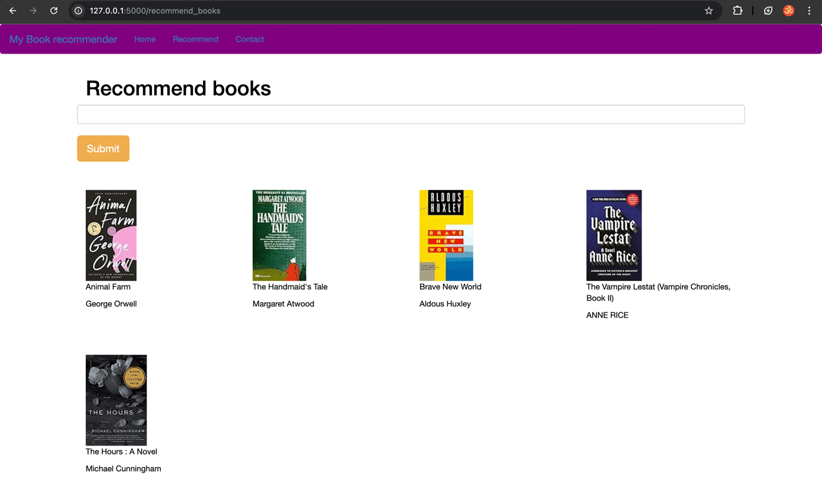

* **Home page:** The first page of the Book Recommendation System

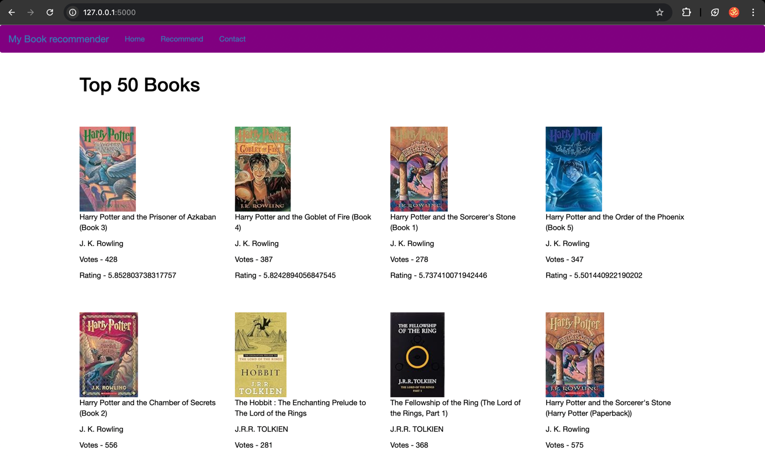

**CONCLUSION AND SCOPE**

The book recommendation system successfully demonstrates the implementation of two distinct yet complementary approaches: popularity-based recommendations and collaborative filtering. Each method addresses different facets of the recommendation challenge, balancing general relevance with personalized suggestions.

The popularity-based system excels in simplicity and effectiveness for new users and those exploring mainstream content. By highlighting books with high average ratings and substantial review counts, it ensures a reliable introduction to widely appreciated titles. However, its generalized nature limits its ability to cater to individual preferences.

The collaborative filtering system, on the other hand, offers tailored recommendations by analyzing user-item interactions. This approach identifies patterns in user behavior, uncovering connections between books and users with similar interests. While collaborative filtering enhances user satisfaction through personalization, its dependence on user engagement and existing data poses challenges, particularly for new users or sparsely rated items.

**Scope and Future Work**

The current implementation lays a strong foundation for a comprehensive recommendation system, but there are several avenues for improvement and expansion:

**1. Hybrid Recommendation System**

Integrate content-based filtering with the existing methods to further enhance recommendation accuracy. By analyzing book metadata (e.g., genre, author, and synopsis), content-based filtering can complement collaborative filtering, particularly in addressing the cold start problem for new books or users.

**2. Incorporating Implicit Feedback**

Leverage user behavior data, such as clicks, reading time, and browsing history, to provide more nuanced recommendations. Implicit feedback can capture user preferences even when explicit ratings are unavailable.

**3. Advanced Machine Learning Techniques**

Adopt advanced algorithms like:

* **Matrix Factorization (e.g., SVD)**: To handle sparse datasets more effectively and uncover latent factors in user-book interactions.
* **Deep Learning Models**: Utilize neural networks to model complex relationships between users and books, enabling richer recommendations.

**4. Scalability and Real-Time Recommendations**

Optimize the system for scalability to handle large datasets and provide recommendations in real-time. Techniques such as approximate nearest neighbors (ANN) for similarity computation can reduce latency.

**5. Diversity and Novelty**

Incorporate mechanisms to ensure recommendations are diverse, introducing users to less familiar genres, authors, or books. Balancing relevance with diversity can prevent monotony in recommendations.

**6. Explainable Recommendations**

Develop features that provide insights into why a particular book is recommended, increasing user trust and engagement with the system.

**7. Multi-Language and Cultural Adaptation**

Expand the system to recommend books in multiple languages and adapt to cultural preferences, making it more inclusive for a global audience.

**8. Community and Social Integration**

Incorporate social features, such as user reviews, book clubs, or recommendations from friends, to enhance user engagement and trust.

**9. Periodic Retraining and Updates**

Regularly update the recommendation models to reflect changing user preferences and emerging trends, ensuring that the system remains relevant over time.

By addressing these areas, the recommendation system can evolve into a more sophisticated, user-centric tool that continues to improve user satisfaction and drive engagement.